# Wexford Creative Game Concept

Author: Alex Bowes Student Number: C00287604

# Time Setting:

My game will be set in modern / viking era of Ireland (795 AD) so I will be designing some structures, Boats and equipment found at Wexford Irish National Hertiage Park

# Game Concept:

The User Will be walking around a modern / Viking era of Wexford where the player walks around while having to completing 3 objectives (games) to help out the Viking village of Weissfjord which was Wexfords original name. The User will be teaming up with Vikings chefs and local marine wildlife to fight pollution while raising awareness about how we can make small changes that can have a big impact by using tips/facts.

## Objectives(Games):

Objectives will be something the player can do to help the Village with there transport , energy production and waste management.

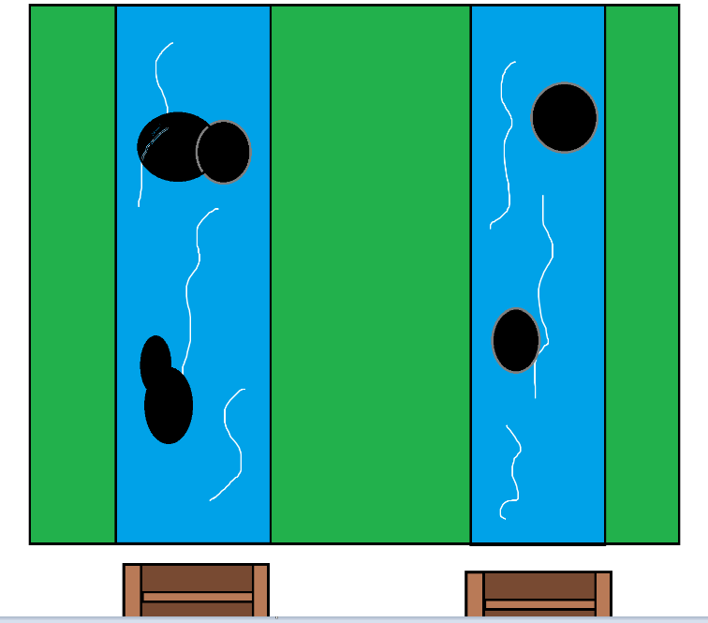Game 1:

This objective is to stop the Village Water wheel from getting blocked from Waste and pollution.

This is a timed objective where the water wheels have health 250 each. To remove the garbage is to click on the waste before it hits the wheel.

The lesson from this game is that we can produce energy/food from running water (river, streams)

Game 2:

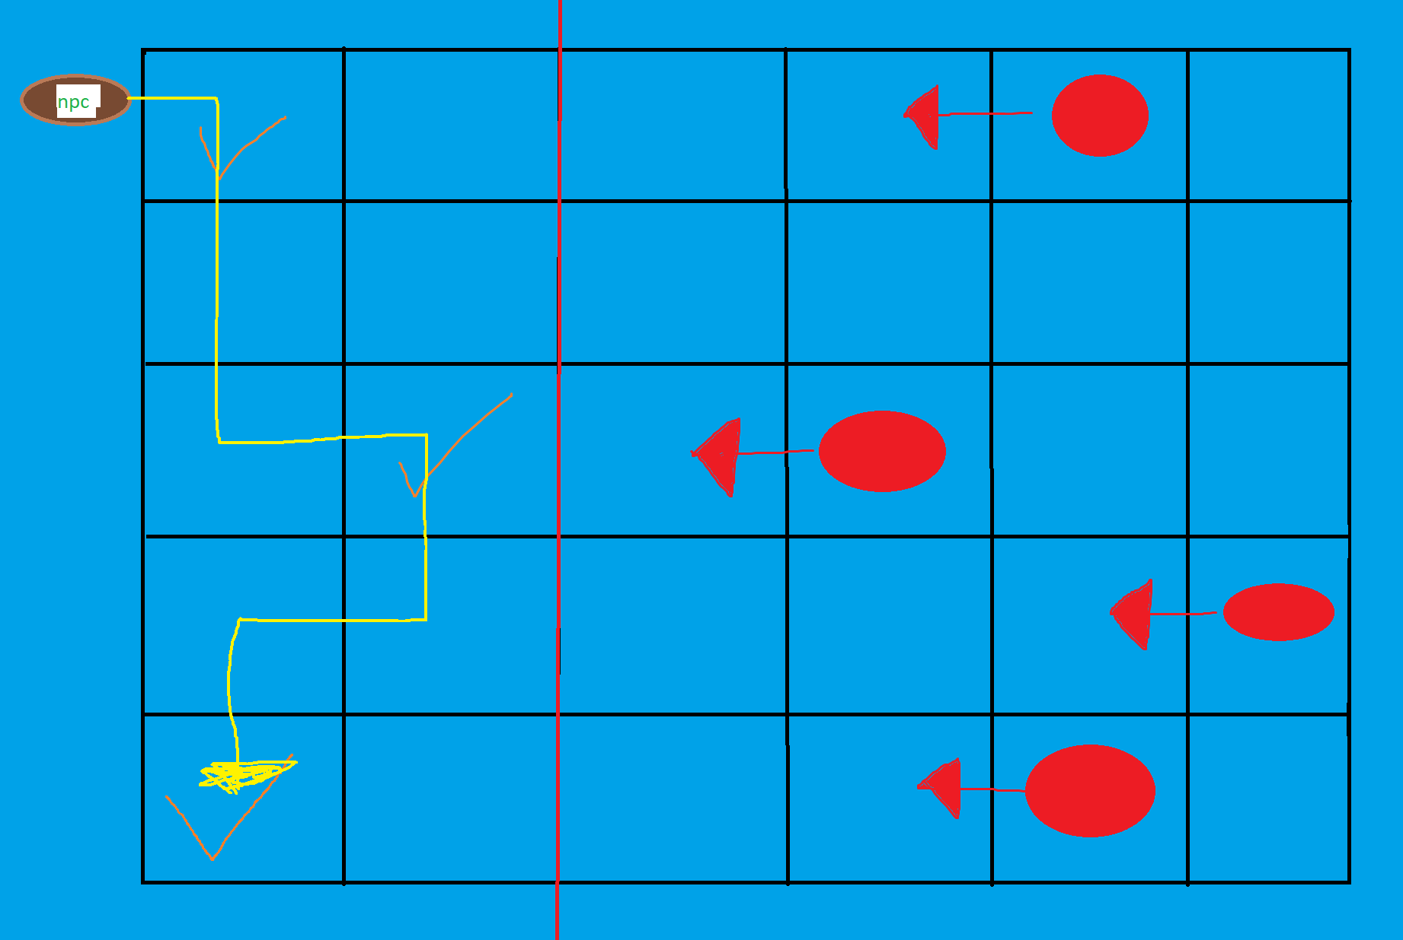

This Objective is where you have to help npc(Vikings) arrive at the checked points to drop giant rocks of limestone and chalk wrapped which will be a 15 second wait at each point the player is with Finn McCool that use a giant hurl and stones to put holes in the enemy ships to send them home and Finn has help from the local wildlife that will help you and the Vikings with your plan. The marine life can slow down the ships or even fling them back home to England.

The lesson in this game is to raise awareness of how important sea life is to our eco system and way of life.

Limestone and chalk have calcium carbonate in them which helps coral reefs grow.

Game 3:

